

Lab 3: Building Tables and one table query practice

LIS464-Applied Database Design

Information School, University of Wisconsin-Madison

**Deliverables:** This word document with questions answered uploaded to the Canvas assignment space.

**Description**: This lab allows you to practice basic SQL syntax by using online interactive learning tool and data manipulation on Akira server. It assumes you have finished the SQL practice exercises.

# Problem Set 1: Build the Student Grade database tables using SQL

This exercise assumes that you have successfully logged into your database account on Akira. Please see the previous Akira connection lab if this is not true.

References:

* Code Academy’s [Manipulation Unit cheat sheet.](https://www.codecademy.com/learn/learn-sql/modules/learn-sql-manipulation/cheatsheet)
* Code Academy [PK and FK](https://www.codecademy.com/resources/docs/sql/primary-keys)
* Autoincrement: https://www.w3schools.com/sql/sql_autoincrement.asp

When you login to Akira, you will see three databases under your account named as User*DB1, User*DB2, AND User*DB2. **We will use User*DB1** for this assignment (double click the DB name until it turns bold).

For the exercises below, you will practice using SQL commands to build tables as per the specifications provided in the table. You will then insert the code into Akira DB1 and generate the tables.

## Exercise 1.1 EXAMPLE Students table with EXAMPLE answers.

|  |  |  |  |  |
| --- | --- | --- | --- | --- |
| ColumnName | Data Type | Key | Required | Other remarks |
| StuNumber | int | PK | Yes | Integer number |
| StuFirstName | Varchar (50) | N | Yes | Up to 50 characters length |
| StuLastName | Varchar (50) | N | Yes | Up to 50 characters length |
| StuEmailAddress | Varchar (120) | N | Yes | Up to 120 characters length |

*In this exercise, you will practice creating tables by writing SQL code.*

### **Example Answer below**

### **Your Code:**

CREATE TABLE Students (  
StudentNumber int NOT NULL AUTO_INCREMENT ,  
StuFirstName varchar(50) NOT NULL,  
StuLastName varchar(50) NOT NULL,  
StuEmailAddress varchar(120) NOT NULL,  
PRIMARY KEY (StudentNumber)  
);

### **Example Image of Table in Akira:**

You must show an image of Akira image for full credit and the image must show your new table in DB1 with each of the columns showing.

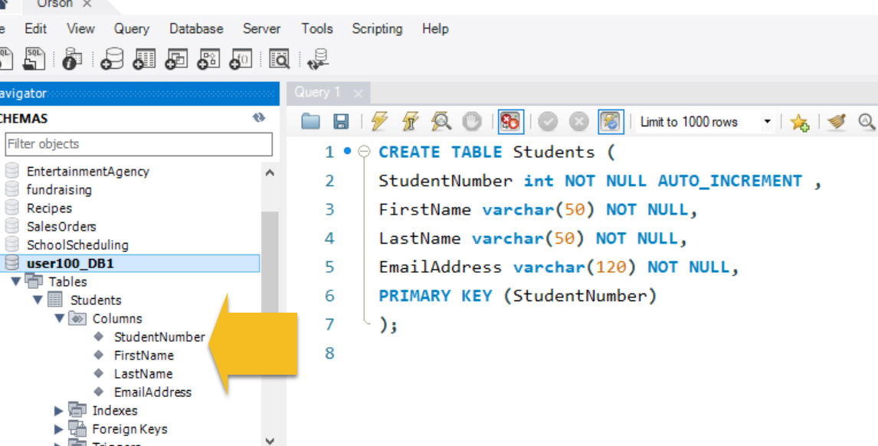

Exercise 1.2 Classes table:

|  |  |  |  |  |
| --- | --- | --- | --- | --- |
| ColumnName | Data Type | Key | Required | Other remarks |
| CourseNumber | int | PK | Yes | Integer number |
| CourseName | Varchar (50) | N | Yes | Up to 50 characters length |
| Term | Varchar (50) | N | Yes | Up to 50 characters length |
| Section | int | N | Yes | Default value set to 1 |

**1.2.1 Your Code:**

CREATE TABLE `user075_DB1`. `Classes` (

CourseNumber int NOT NULL AUTO_INCREMENT ,

CourseName varchar(50) NOT NULL,

Term varchar(50) NOT NULL,

Section int NOT NULL DEFAULT 1,

PRIMARY KEY (CourseNumber)

);

**1.2.2 Image of table in Akira:**

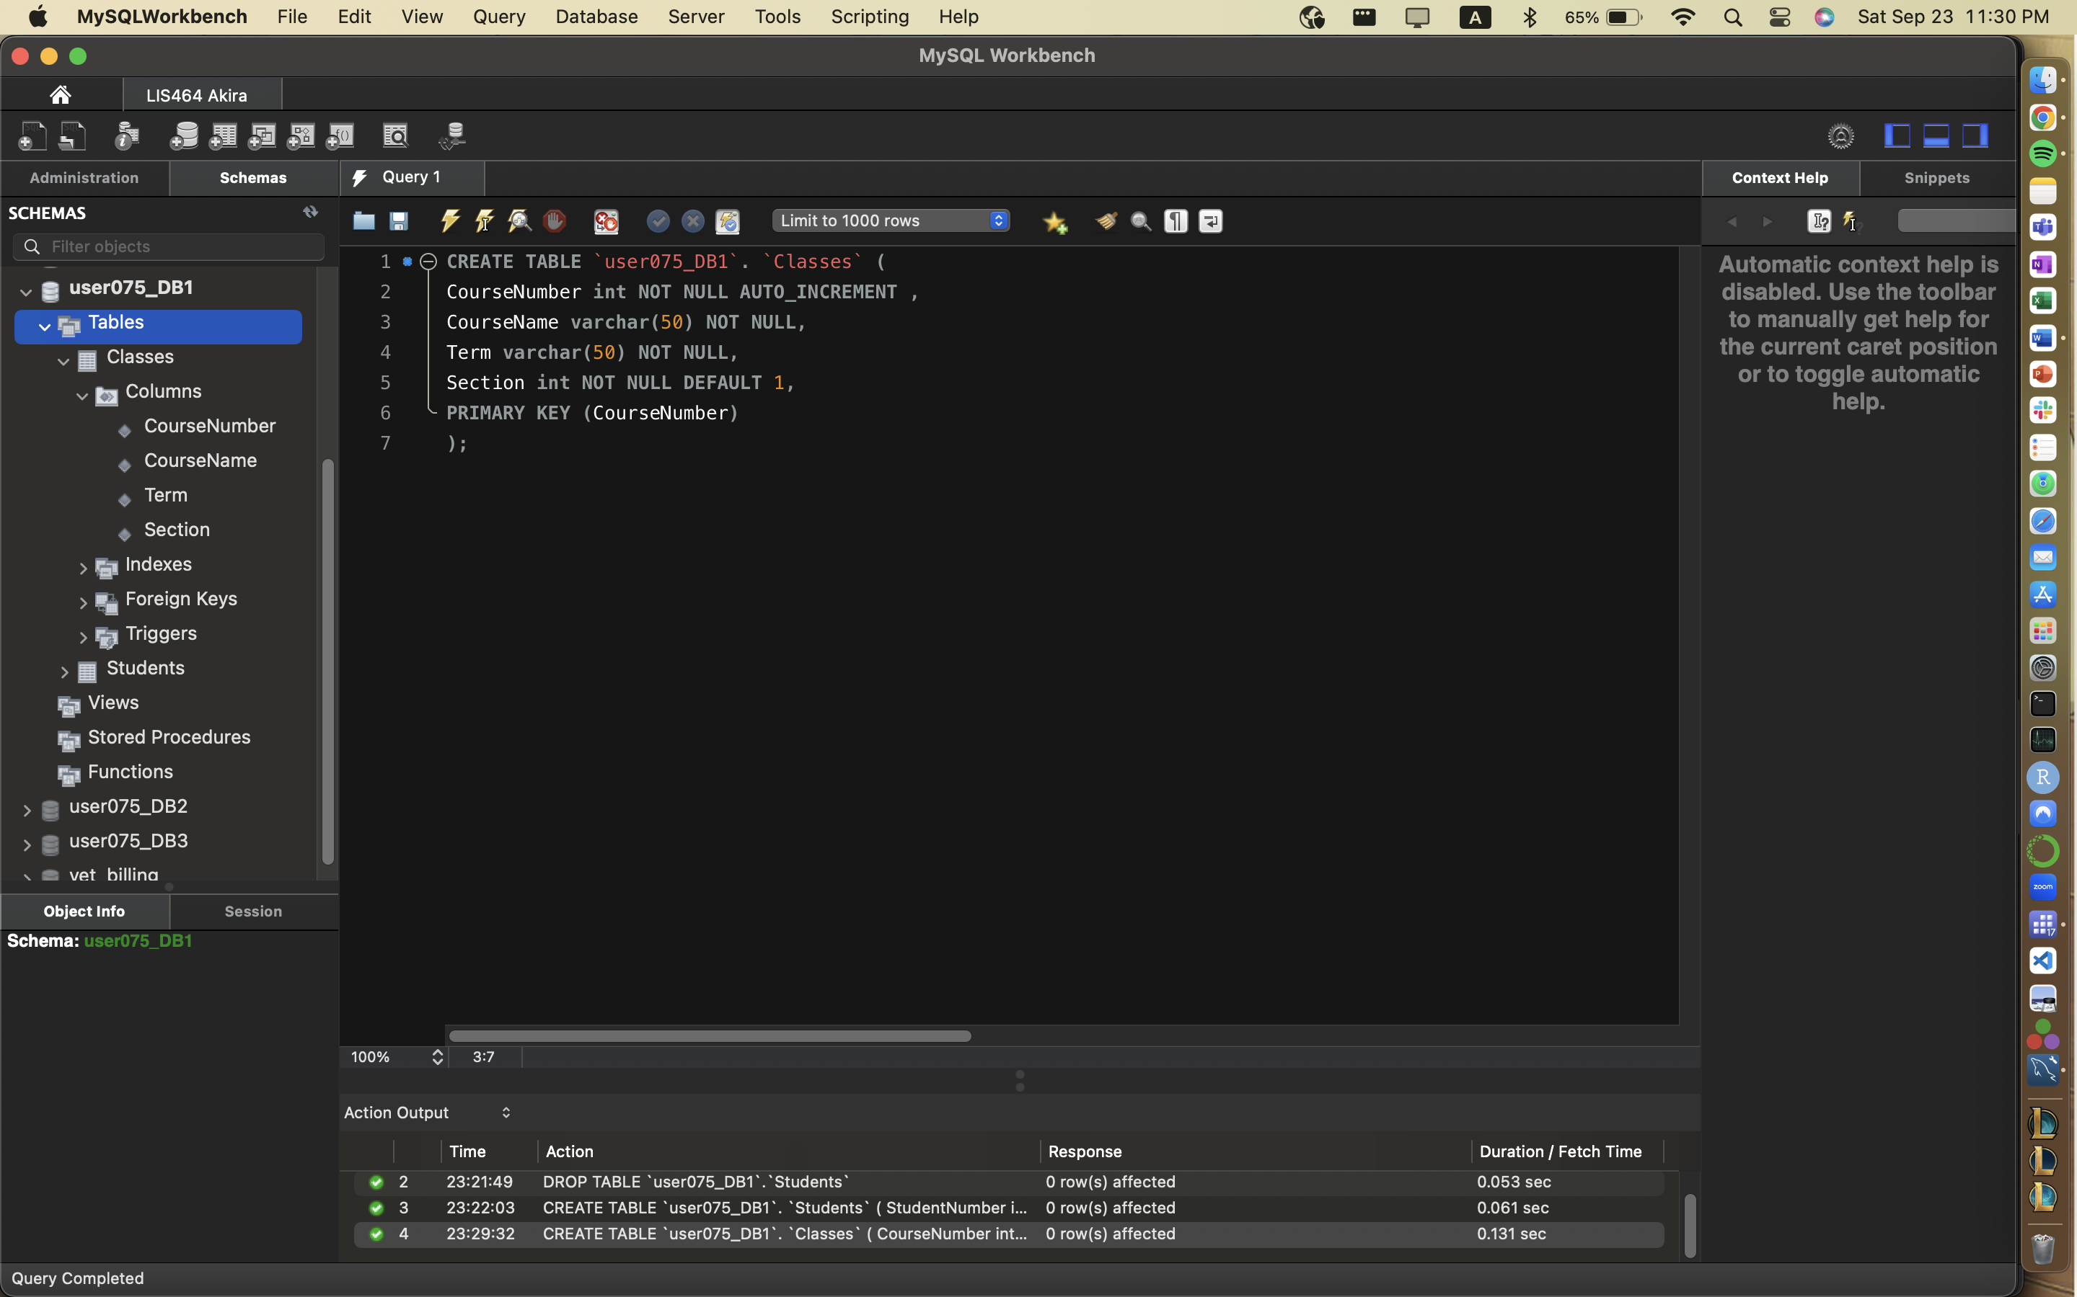

## Exercise 1.3: Grades table

|  |  |  |  |  |
| --- | --- | --- | --- | --- |
| ColumnName | Data Type | Key | Required | Other remarks |
| GradeID | INT | PK | Yes |  |
| StudentNumber | INT | FK | Yes | Integer number |
| CourseNumber | INT | FK | Yes | Integer number |
| GradeScores | DECIMAL | N | Yes | Decimal number, fixed, scale=2, decimal points=1 |

***Hint: to define the decimal, use Scores Decimal (2,1)***

Ref: <https://dev.mysql.com/doc/refman/5.7/en/precision-math-decimal-characteristics.html>

<https://www.w3schools.com/sql/sql_datatypes.asp>

**1.3.1 Your Code:**

**CREATE TABLE `user075_DB1`. `Grades` (**

**GradeID int NOT NULL,**

**StudentNumber int NOT NULL,**

**CourseNumber int NOT NULL,**

**GradeScores decimal(2,1) NOT NULL,**

**PRIMARY KEY (GradeID),**

**FOREIGN KEY (StudentNumber) references Students(StudentNumber),**

**FOREIGN KEY (CourseNumber) references Classes(CourseNumber)**

**);**

**1.3.2 Image of table in Akira:**

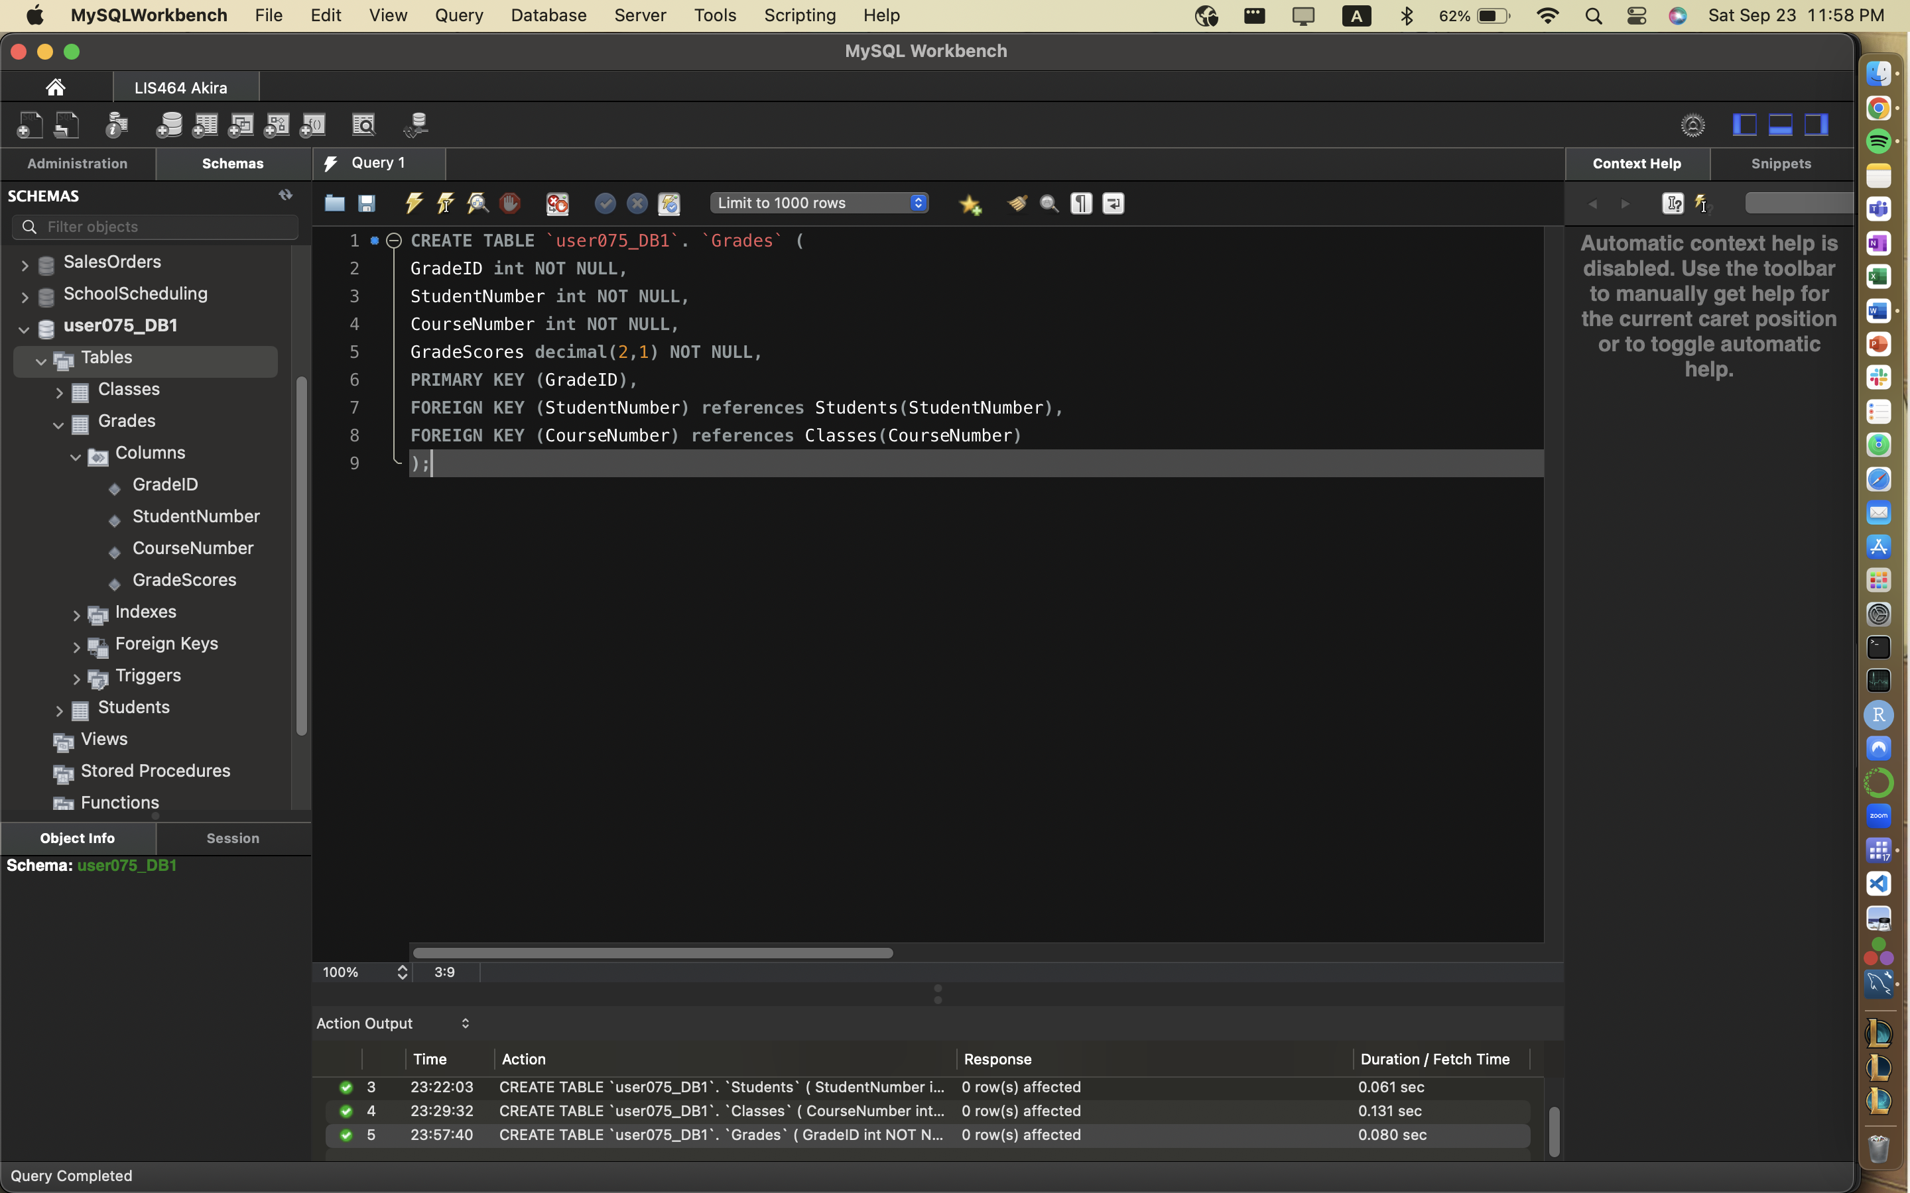

Exercise 1.4 Add Data

Use SQL to insert at least one record of data that you create into the students table.

**1.4.1 Your Code:**

INSERT INTO `user075_DB1`. `Students` (`StudentNumber`, `StuFirstName`,`StuLastName`,`StuEmailAddress`)

VALUES

('1', 'Timmy', 'Johnson', 'tj@gmail.com'),

('2','Martha','Schwartz','ms@gmail.com'),

('3','Carlyle','Bizz','cb@gmail.com');

**1.4.2 Image of table in Akira:**

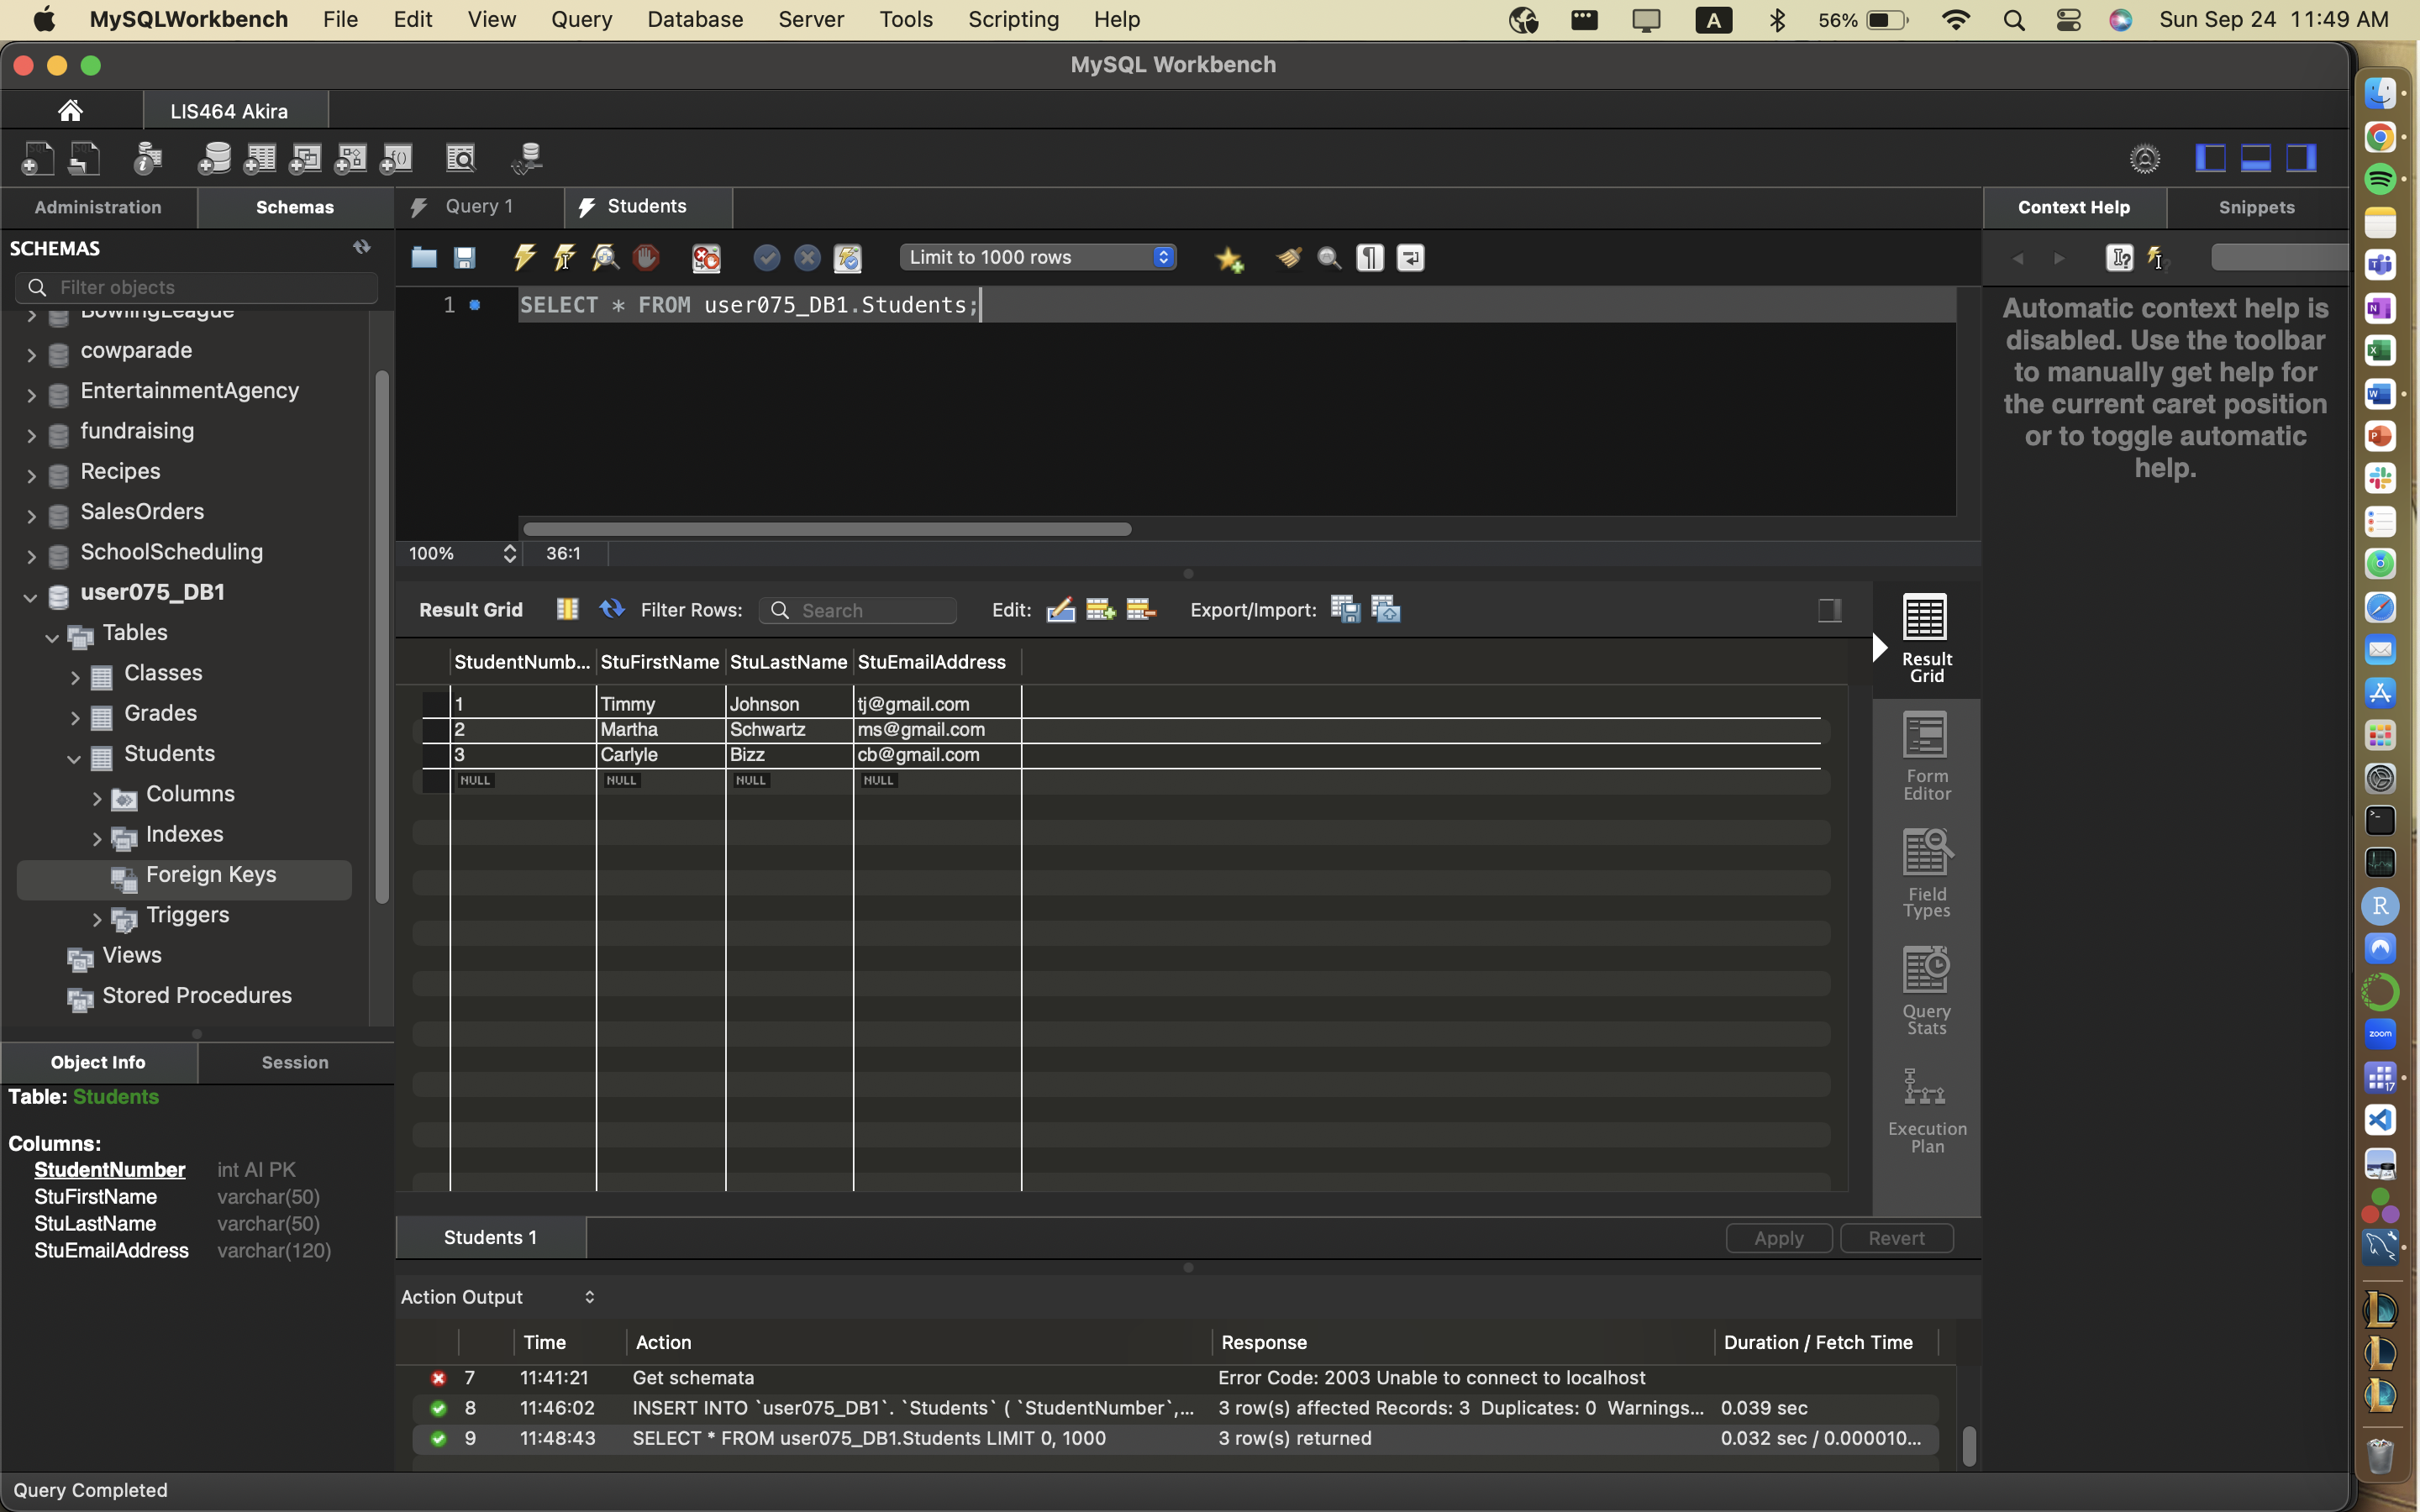

# Task 2: Practice uploading sql files into Akira - creating the View Ridge Gallery (VRG) database

**Introduction**:

*In this exercise, you will practice loading pre-existing database files onto a server.*

The database has been designed as shown in the ERD below:

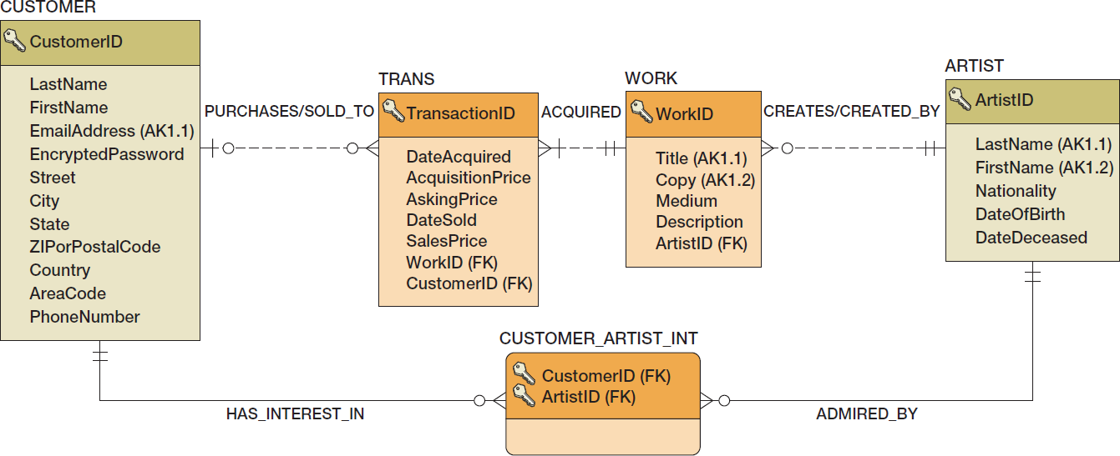

Please follow the steps below to build and manipulate the database (tables):

1. Once you log into your database account, you should see the following window.

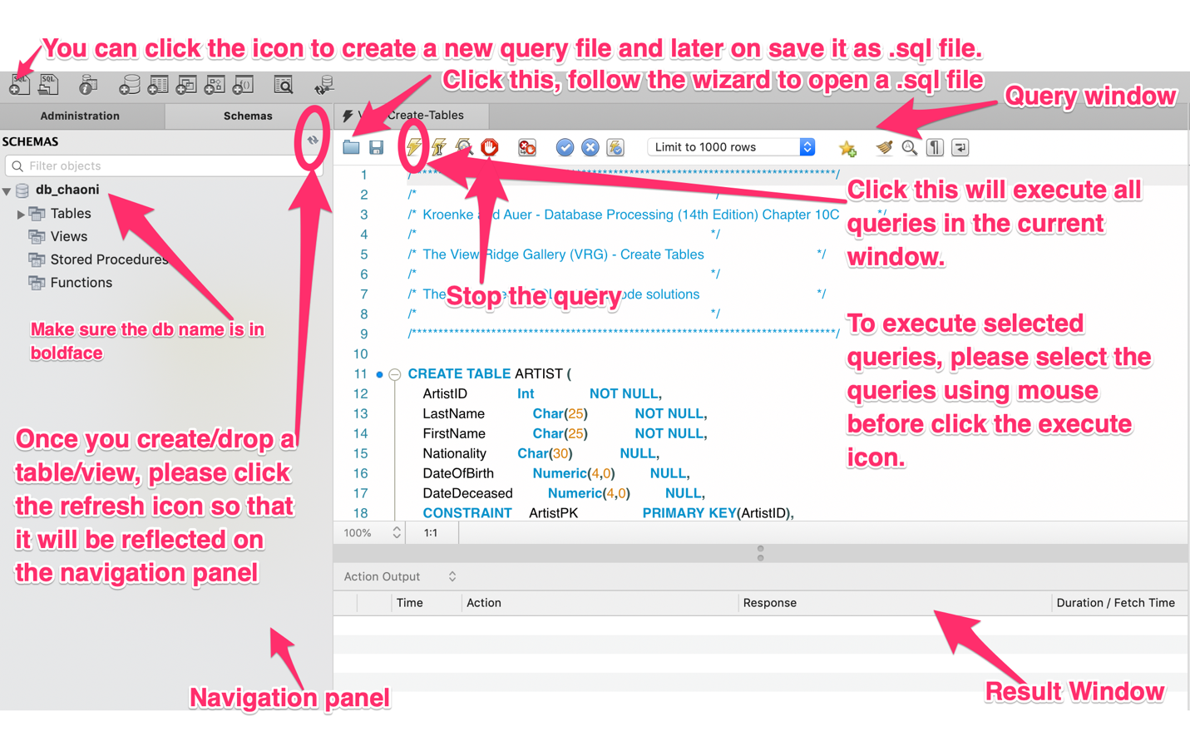

1. You will see three databases under your account named as User*DB1, User*DB2, AND User*DB2. **We will use User*DB2** for this assignment (double click the DB name until it turns bold).
2. Please load the VRG-Create-Table.sql file by clicking the folder icon (see the screenshot above) and navigating to a locally saved version of VRG-Create-Table.sql You can also use File/Open SQL Script.
3. Please read through each **create table statement CAREFULLY**. You should see five create statement in the file.
4. Please click the Execute icon to execute the five create table statements (See the screenshot above.)
5. Once done, you should be able to see a list of five tables under the Tables category on the navigation panel of MySQL Workbench. If you don’t see them, please refresh (screenshot above)
6. Please open the VRG-Insert-Data.sql files. This file includes **insert** statement that insert **values** into tables built in the previous step. Please read the script carefully and execute them.
7. You should see data in your five tables.
8. Once you have loaded the tables and the data, you have completed Task 2.

# Task 3: One Table Query Practice

Please write the SQL query for the following questions and **paste the query and it returned results below**. Note that you will need to create a new query file (**See the screenshot above for how to**) for you to write down the following queries.

Cheatsheet: https://www.codecademy.com/learn/learn-sql/modules/learn-sql-queries/cheatsheet

**How to provide SQL query answers.**

To ensure you get full credit for each SQL query problem please make sure that:

1. You show the full query (1 below)
2. You only need to show the top 5 results. If there are fewer than 5 rows in the results, show all of them (2 below)
3. You need to show the number of rows produced in the Action Output bar. To do so, clear the history so your query shows in the top line of the output (3 below)

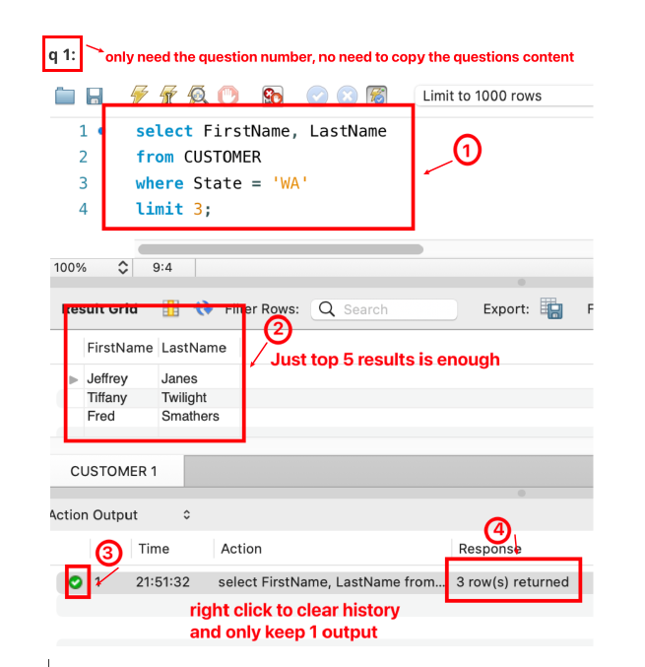

## **Query 3.1. VRG database – Please list the title, medium and description of all works.**

Learning objective: selecting selected fields within a table.

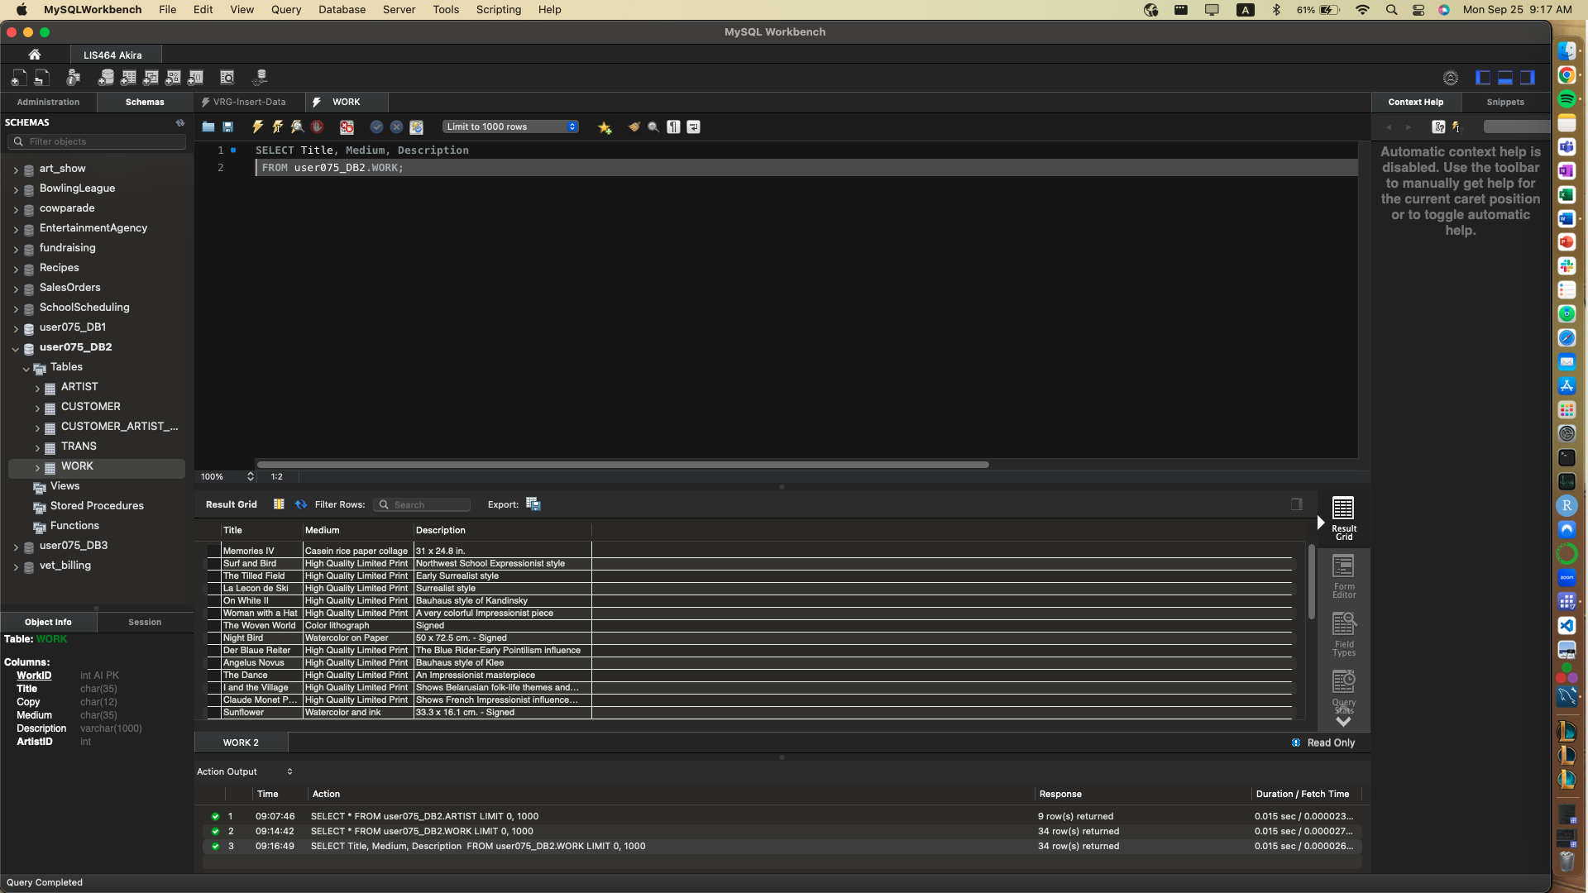

## **Query 3.2 VRG database - Please find the names of artists who were born before 1914.**

Learning objective; WHERE clause delimiters

Hint: https://www.codecademy.com/courses/learn-sql/lessons/queries/exercises/where

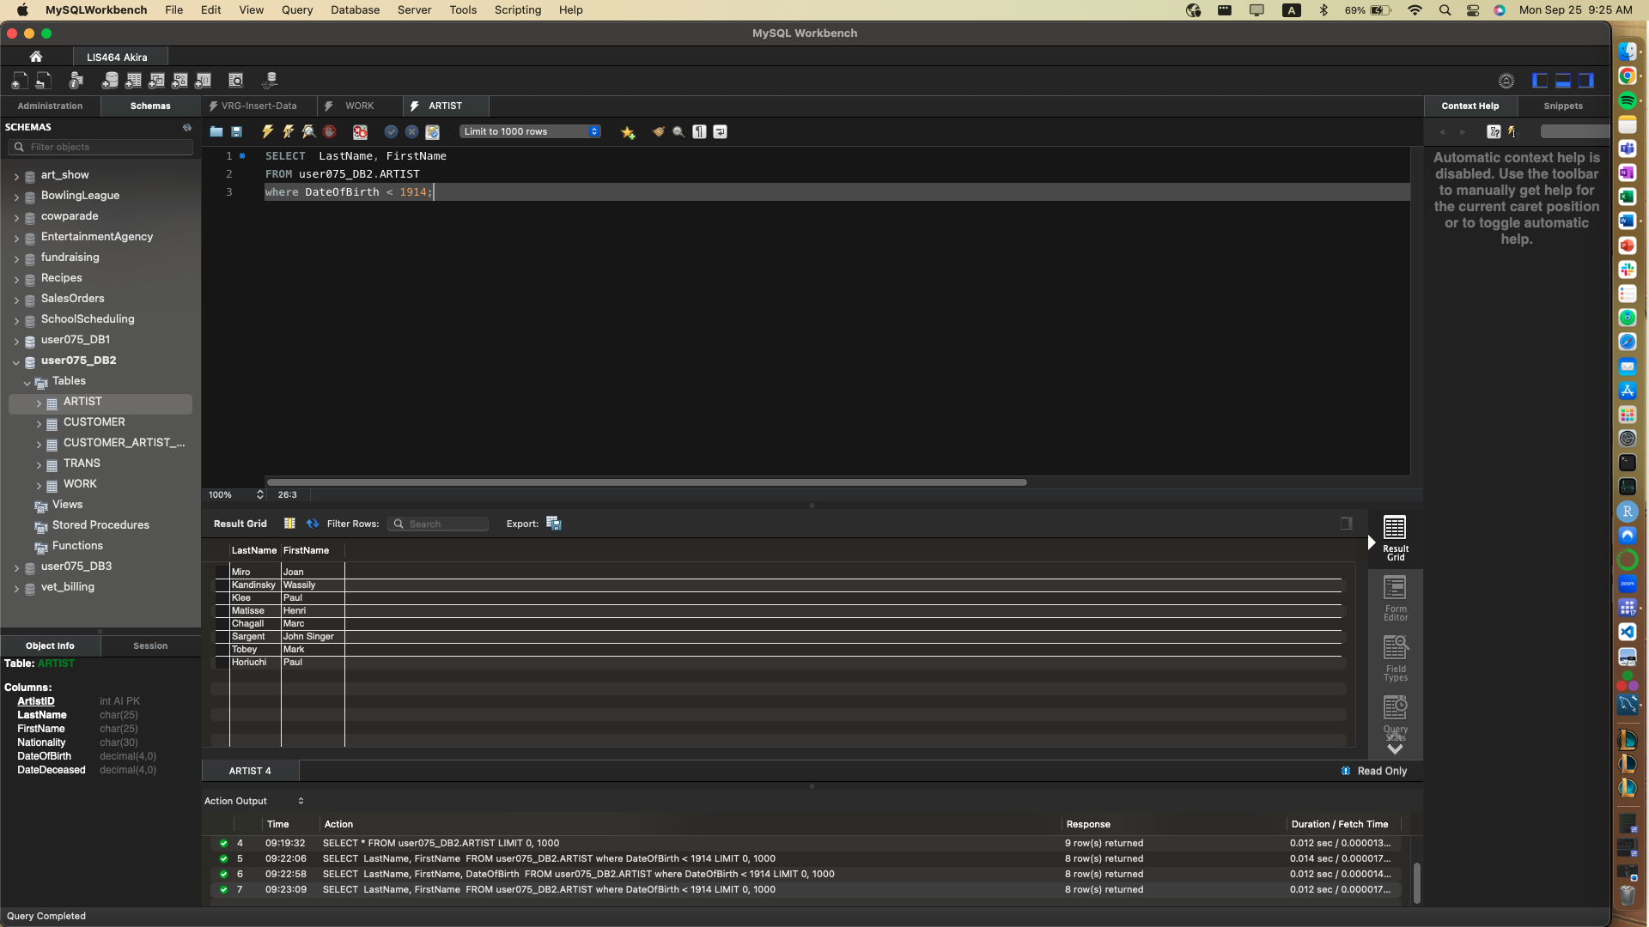

## **Query 3.3. VRG database - Please select the details (all the features) for the first 5 works in from the WORK table after ordering them by their title descending. (reverse alpha order)**

Learning objectives: LIMIT, ORDER BY DESC

Hints: https://www.codecademy.com/courses/learn-sql/lessons/queries/exercises/limit

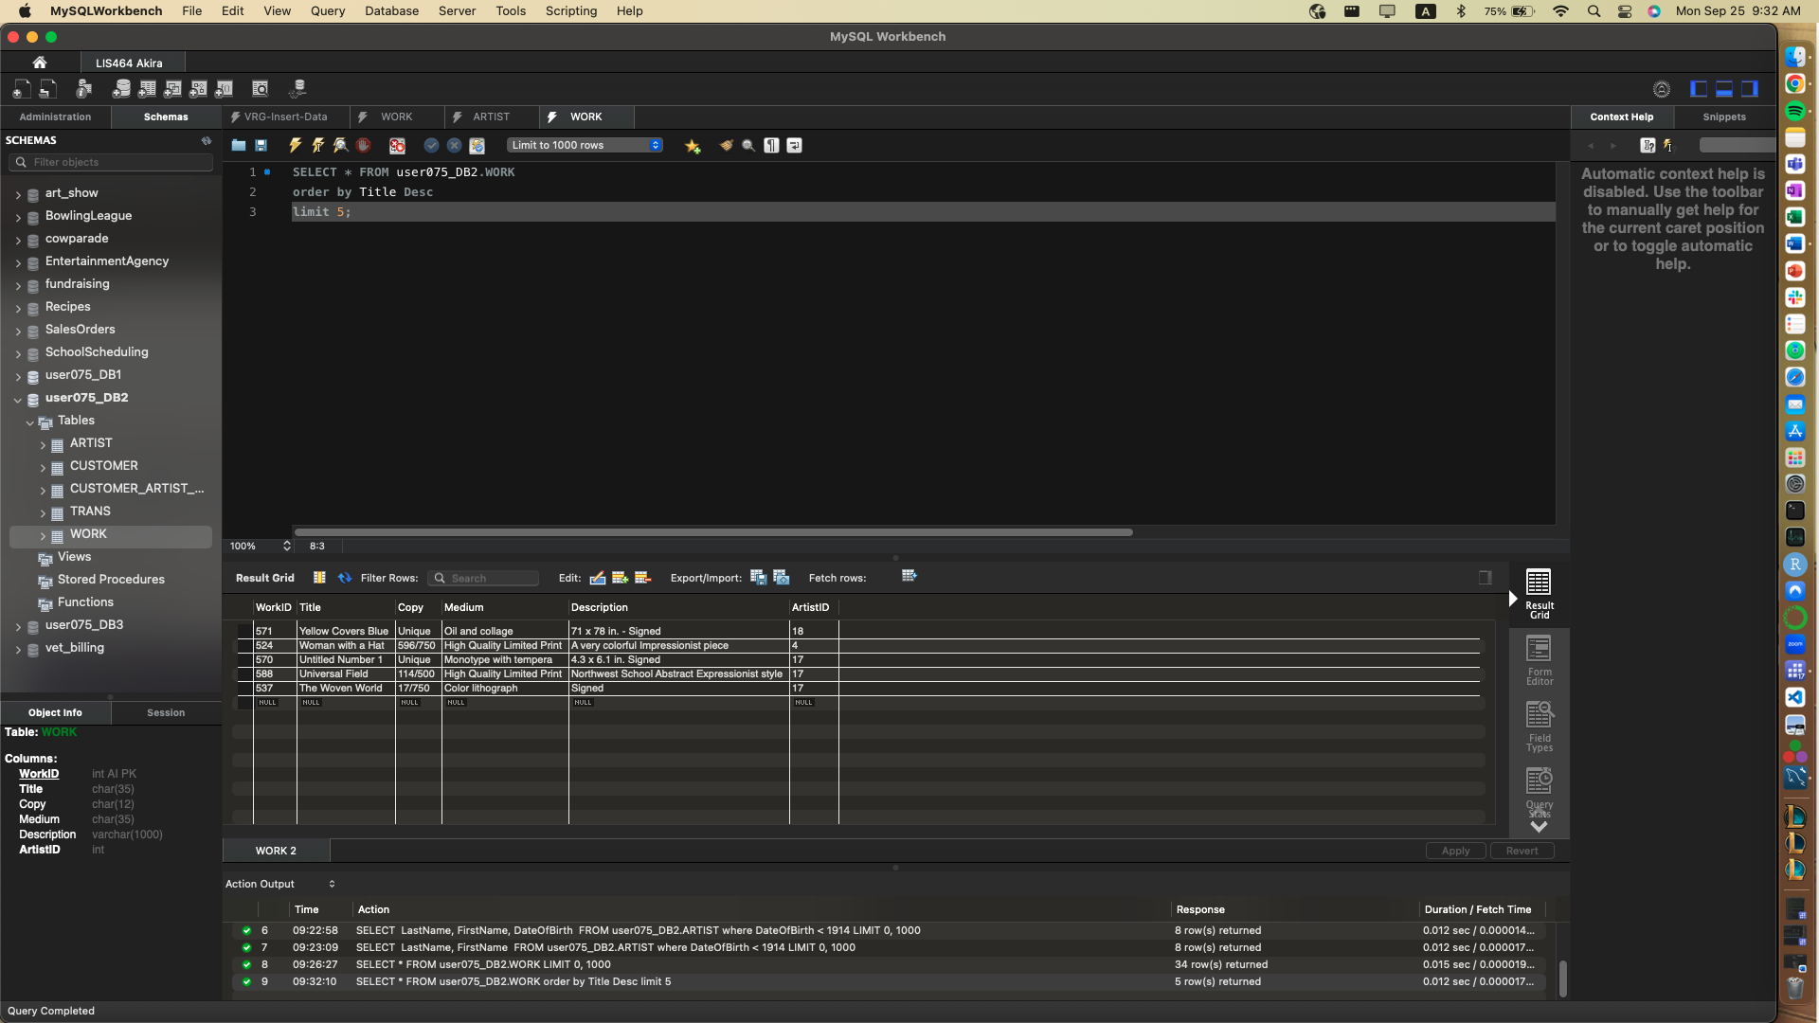

## **Query 3.4 Switch to the vet_billing database**. **Search the ANIMAL table and list the animal name and animal id numbers for just those animals with no owner.**

Learning objective: NULL

Hint: https://www.codecademy.com/courses/learn-sql/lessons/queries/exercises/is-null

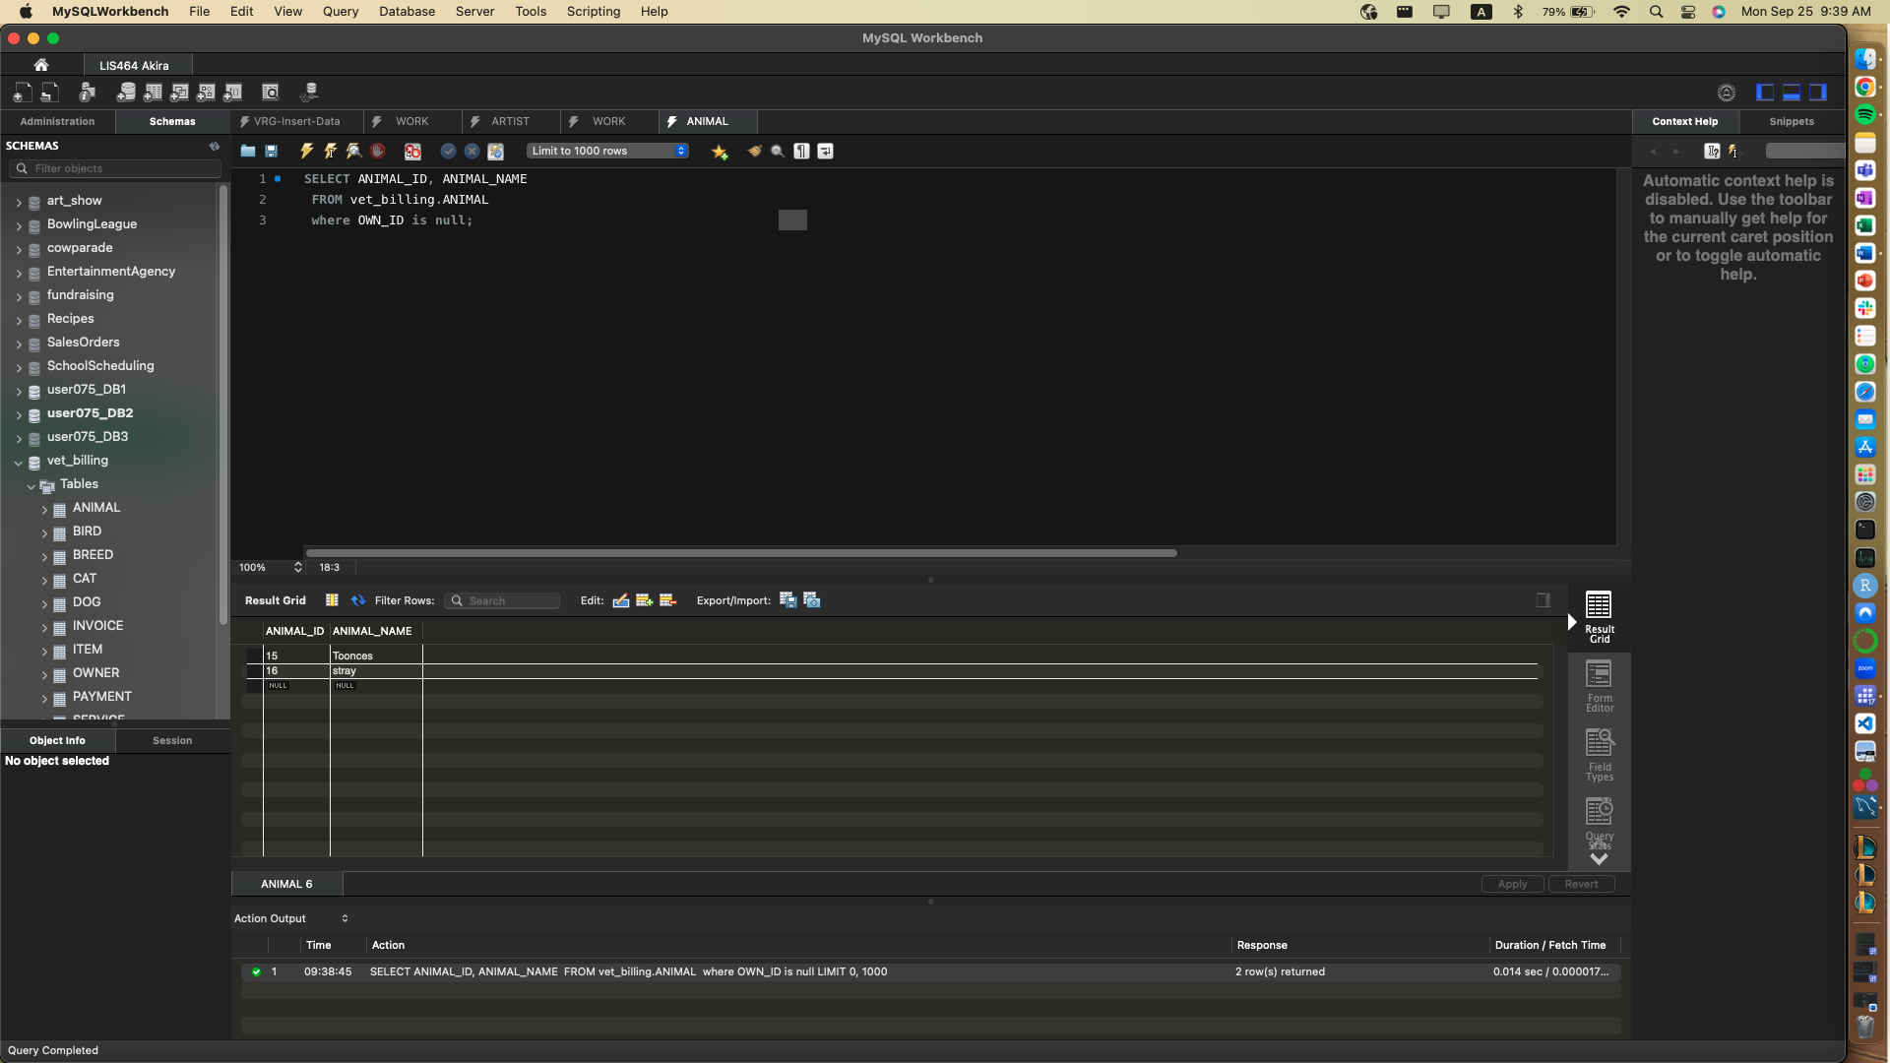

## **Query 3.5. Using vet_billing, list all the information for animals that are dogs or that have owner 12.**

Learning objective: OR

Hint: https://www.codecademy.com/courses/learn-sql/lessons/queries/exercises/or

